“So Swiss” —— Sino-Swiss Joint Program Chinese Teaching Team in the Management Department Participated in “So Swiss” Pop-up Event.

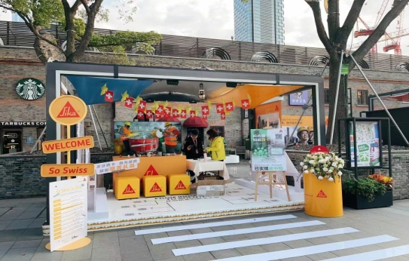
The purpose of this trip is to further enhance the synergy of the Sino-Swiss Co-education -- International Business (Tourism and Business Management) teaching team in the Department of Management and strengthen the close relationship with the Swiss Chamber of Commerce in Shanghai.

On the afternoon of November 23rd, the Chinese teaching team from the Sino-Swiss Joint Program was invited to participate in the "So Swiss" pop-up event held in Jinchao 8 Lane, Hongkou District. They had an immersive experience of refreshing Swiss innovation, technology and culture.

This event is originated from the “Pop-up House of Switzerland” event launched last year. The idea is to bring Switzerland to the people, to literally pop-up in their neighborhood or favorite places. Therefore, “Pop-up House of Switzerland” is launched in Shanghai as an Asian premiere.

The activity was an immersive experience for the Chinese teaching team of the Sino-Swiss Joint Program. We saw exquisite snow houses and airplane models at the joint booth of Swiss National Tourism Office and Swiss Air, and learned about the concept of "Swiss sustainable tourism".

Through this activity, the teaching team deeply experienced the charm of Swiss technology and culture. Besides, this activity also played a positive role in promoting the teaching quality of the Sino-Swiss Joint Program.

Report and photo by：Management Department—Yuhan Xiao
2022.11.24

